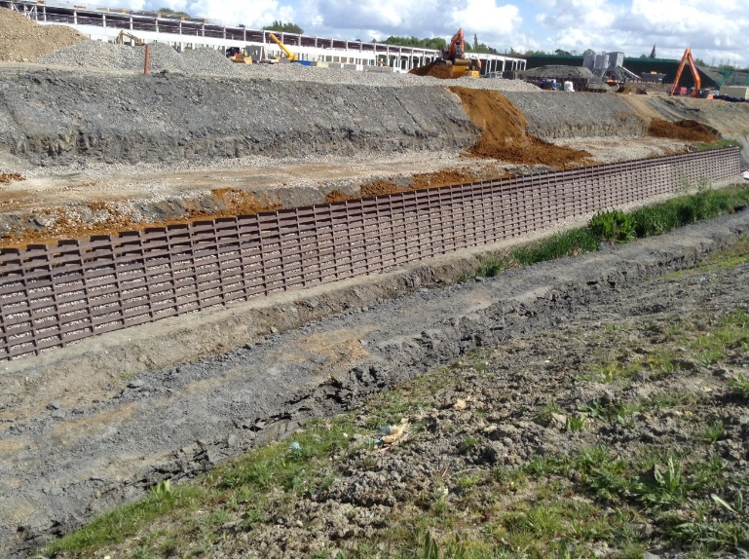
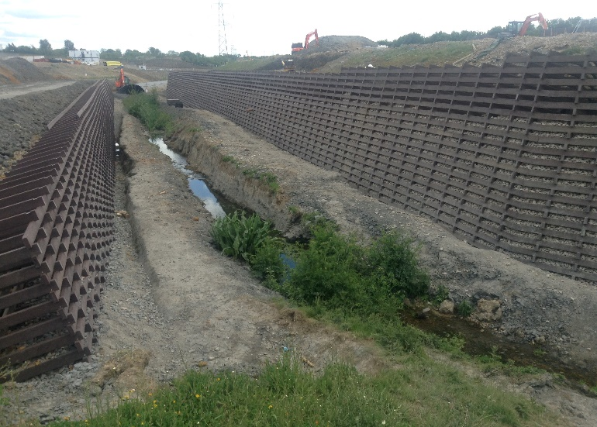
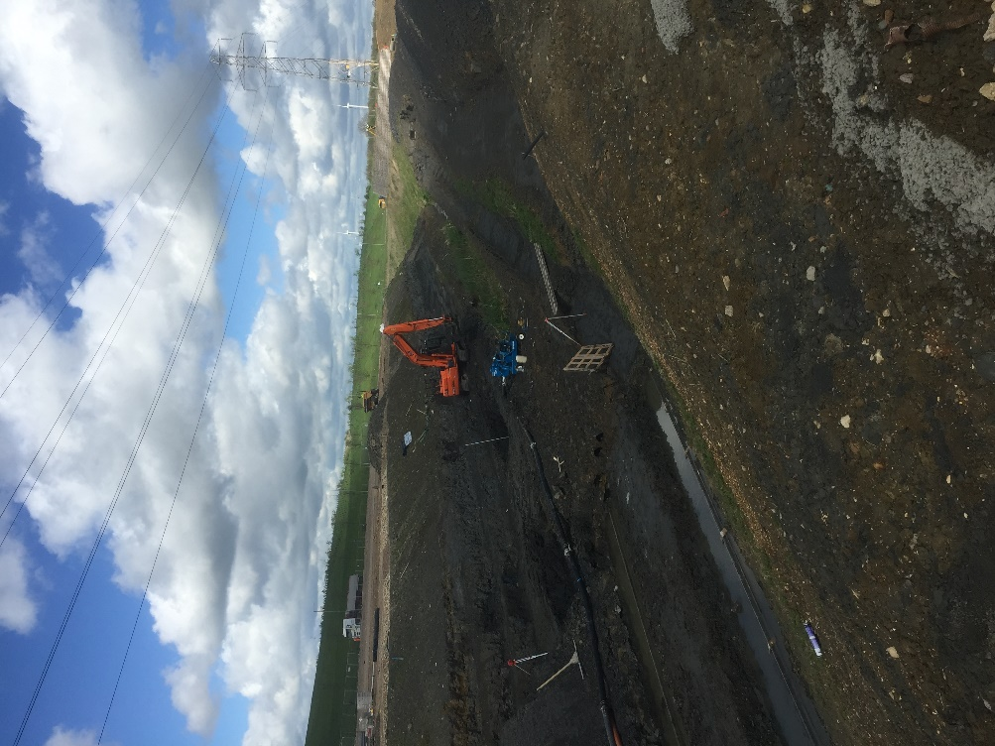
ECOCRIB CASE STUDY
JF Finnegans, Costco Warehouse, Crick
PROJECT IN BRIEF

LOCATION: Crick, Northamptonshire
CLIENT: JF Finnegans
CONSULTING ENGINEER: Quattro Consult
MAX. RETAINED HEIGHT: 5.2m
FACE AREA: 1576m²
PLASTIC WASTE DIVERTED FROM LANDFILL: 140 tonnes

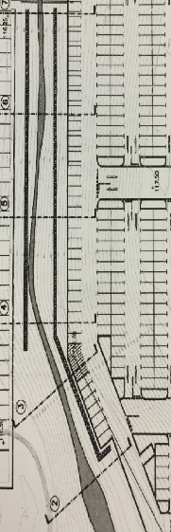
PROJECT IN FULL

The Challenge
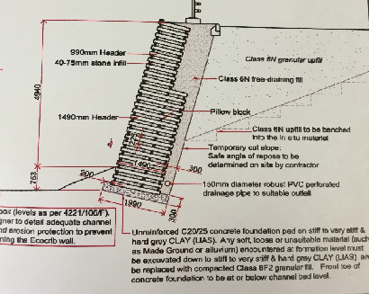
A site in Crick, Northamptonshire, had been chosen to hold one of their distribution warehouses by the internationally known group Costco, this site will be a huge unit that supplies stock to its 27 sites across the UK.
We specialise in reinforced earth and retaining wall systems and with our new Ecocrib, the client was very happy to proceed as the benefits were outstanding as opposed to any other retaining wall system.
The challenge for this project was the small amount of natural occurring water that needed to be retained but the space needed for the sites car parking stretched across both sides of this water. The client (Finnegans) wanted a suitable system that had a reputation for 100% success and that would last for a considerable amount of time.
The Solution
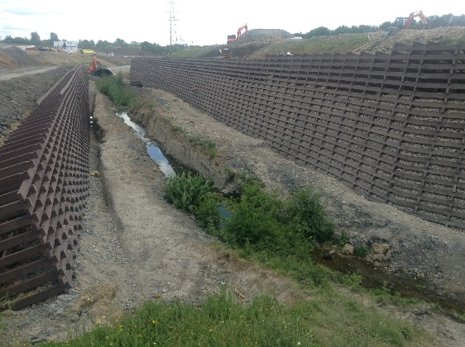
An Ecocrib mass gravity retaining wall now supports a part of the car park at Costco’s new development. Designed, supplied and installed by PC Construction. Awarded a BBA HAPAS certificate in 2012 with a design life in excess of 120 years, Ecocrib is structurally robust yet the most highly sustainable retaining solution currently available for developments that require retaining walls.
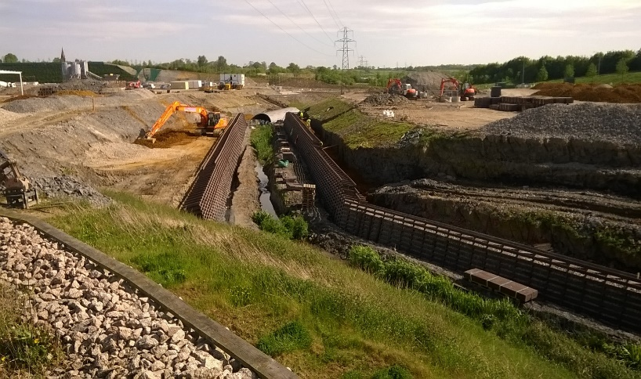
Developed from timber crib technology, the 50mm x 125mm Ecocrib profiles are considerably more durable than treated timber but possess many of the environmental benefits. Ecocrib profiles are manufactured entirely from recycled UK plastic waste with any wastage or surplus material re-processed to form new Ecocrib profiles. Ecocrib can be recycled when it reaches the end of its useful life.
1576 SQM of Ecocrib was used on the scheme equivalent to 27.5 million plastic bottle tops or 140 tonnes of plastic waste diverted from landfill.
Bellway homes have used us numerous times for Ecocrib solutions as have many of the biggest house building companies in the UK and its becoming a trend, if you need a retaining wall then the best solution is the most beneficial solution, Ecocrib!

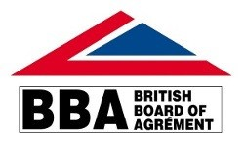
CASE STUDY
WWW.ECOCRIBWALL.CO.UK

